Project Report Template  1.INTRODUCTION  1.1 overview . The global human population reached 8.0 billion in mid-November 2022 from an estimated 2.5 billion people in 1950, adding 1 billion people since 2010 and 2 billion since 1998.

* 1.2 purpose Define Problem / Problem Understanding o Specify the business problem
  + Business requirements
  + Literature Survey

### social and business impact. 2.Problem definition and design making 2.1 Empathy Map 2.2 Ideation and Brainstroming MapC:\Users\VAISHNAVI\OneDrive\Pictures\Screenshots\Screenshot (15).png3.Results C:\Users\VAISHNAVI\OneDrive\Pictures\Screenshots\Screenshot (2).pngC:\Users\VAISHNAVI\OneDrive\Pictures\Screenshots\Screenshot (3).pngC:\Users\VAISHNAVI\OneDrive\Pictures\Screenshots\Screenshot (4).pngC:\Users\VAISHNAVI\OneDrive\Pictures\Screenshots\Screenshot (7).pngC:\Users\VAISHNAVI\OneDrive\Pictures\Screenshots\Screenshot (1).pngC:\Users\VAISHNAVI\OneDrive\Pictures\Screenshots\Screenshot (5).pngC:\Users\VAISHNAVI\OneDrive\Pictures\Screenshots\Screenshot (14).png44C:\Users\VAISHNAVI\OneDrive\Pictures\Screenshots\Screenshot (10).png4.Advantages and Disadvantages **1. More people leads to greater human capital**. **2. Higher economic growth.** **3. Economies of scale.** **4. The efficiency of higher population density.** **5. The improved demographic structure of society.** **6. Critical mass.** Disadvantages

# **1. Cost to the environment.** Population growth exacerbates many of the existing environmental problems. **2. Congestion**. Too many people in a small space will lead to various types of congestion. **3. Water shortages**. Already up to 40% of the world’s population face water scarcity . **4. Generating unsustainable waste.** C:\Users\VAISHNAVI\OneDrive\Pictures\Screenshots\Screenshot (16).png 5.APPLICATIONS Population growth rates: issues and an application.

 increased economic growth of a country, growing demand for jobs, lack of housing and schools, lack of infrastructure leading to poor living, and increase in pollution and waste. 6.CONCLUSION Tracing of the growth of global community A population forecasting analysis .  It is expected to surpass 8 billion people by 2025, 9 billion by 2040, and 11 billion by 2100. 7.FUTURE SCOPE Towards the end of the century, the UN expects the global population to reach its peak at around 10.4 billion.  India's population is set to rise to 1.515 billion in 2030, from 1.417 billion in 2022. 8.APPENDIX 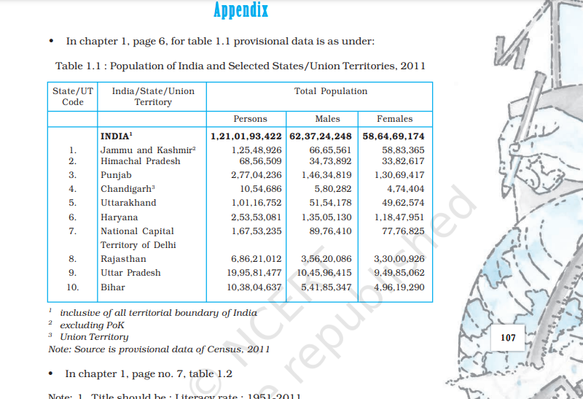Total Population. Code. Territory. Persons. Males. Females. INDIA1. **1,21,01,93,422** 62,37,24,248 58,64,69,174. 1. Jammu and Kashmir2. The population projections used by the committee are based on intermediate-cost population projections prepared by the Social Security Administration (SSA) for its 2011 Trustees Report, with some important modifications.

National Academies of Sciences, Engineering, and Medicine. 2012. Aging and the Macroeconomy: Long-Term Implications of an Older Population.